Guilherme Maciel

Rubin Tapia

Andrew London

CIS 3260 – 012 Professor Alan T. Yang

Saturday December, 3 2016

**Testing Requirements Group Project**

**Student Specific Test Cases**

**1. Create a new student and assign him/her**

-Student ID

-Name

-GPA

-Graduation Year

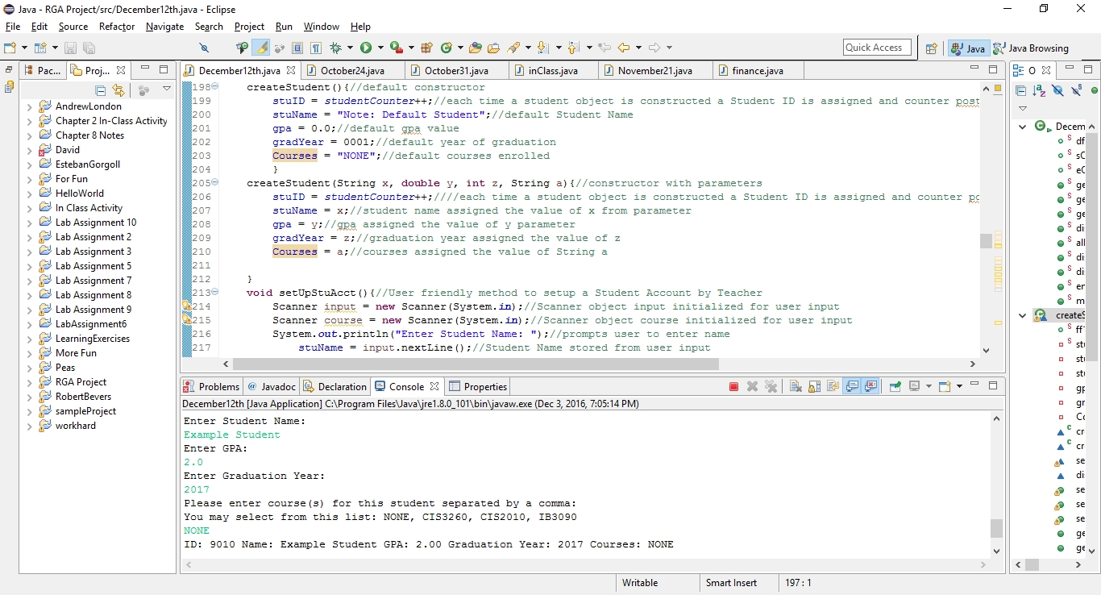

**2. Modify Student GPA**

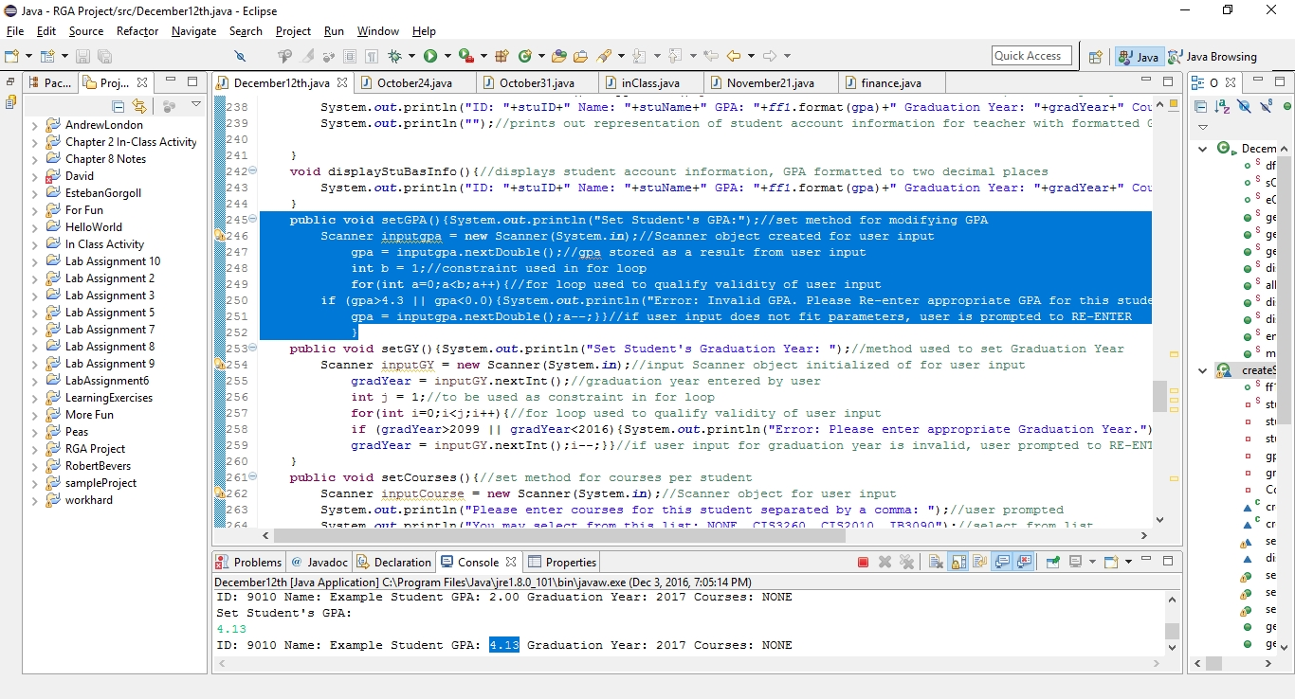

**3. Modify Student Graduation Year**

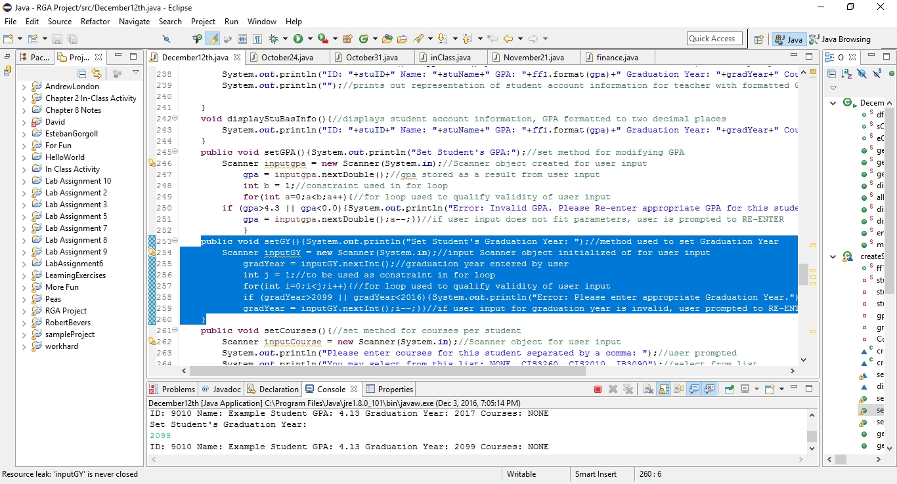

**4. Default values of GPA: 0.0 & Graduation Year: 0001**

**&**

**5. Display a Student’s Name, GPA, & Year of Graduation**

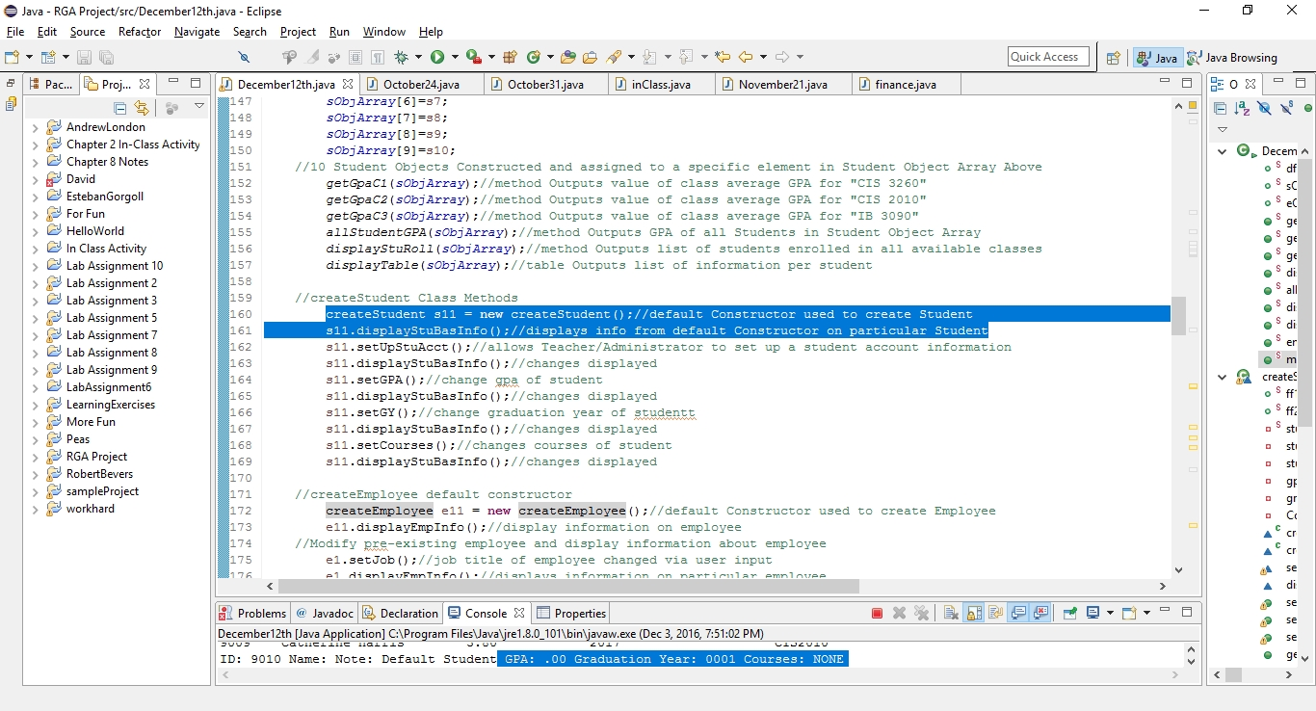

**6. Students can join courses**

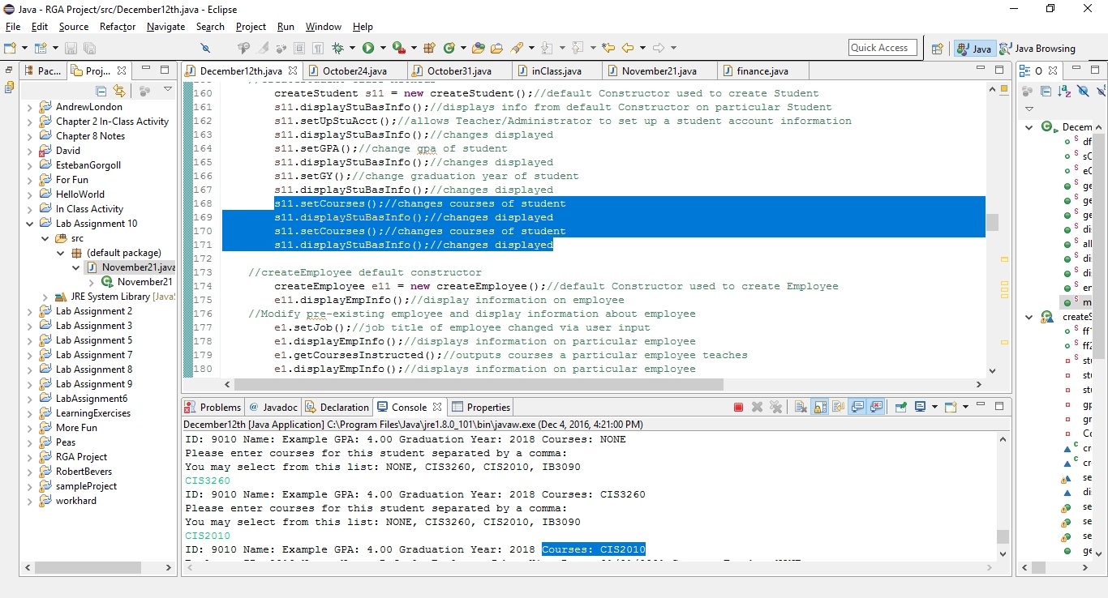

**7. Average GPA of Students in a Course:**

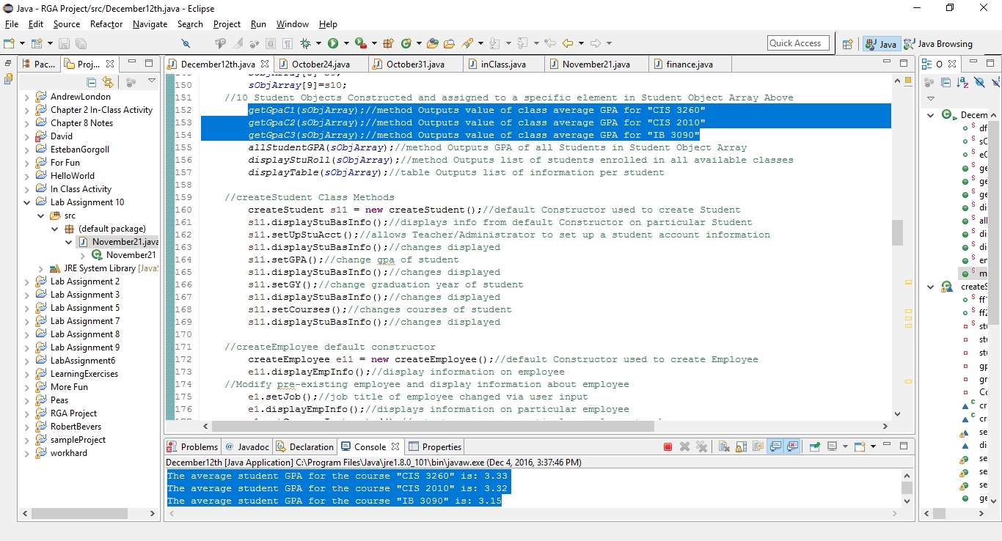

**8. Display a list of students taking a particular course**

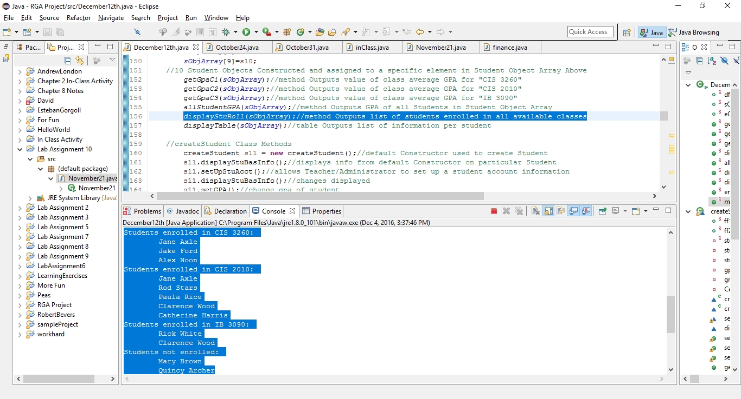

**9. Student Table & 10 Student Objects**

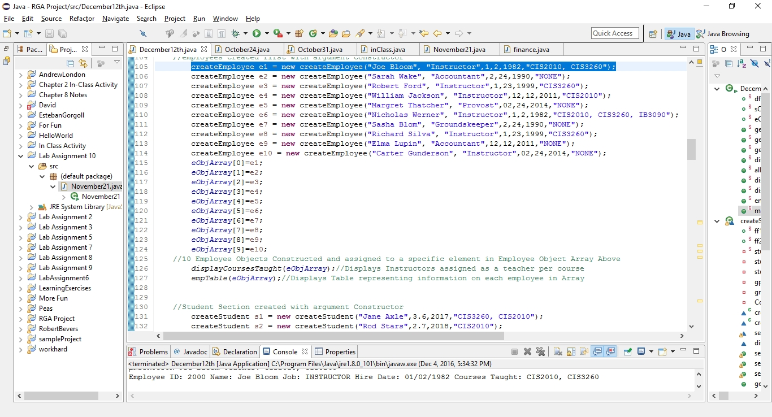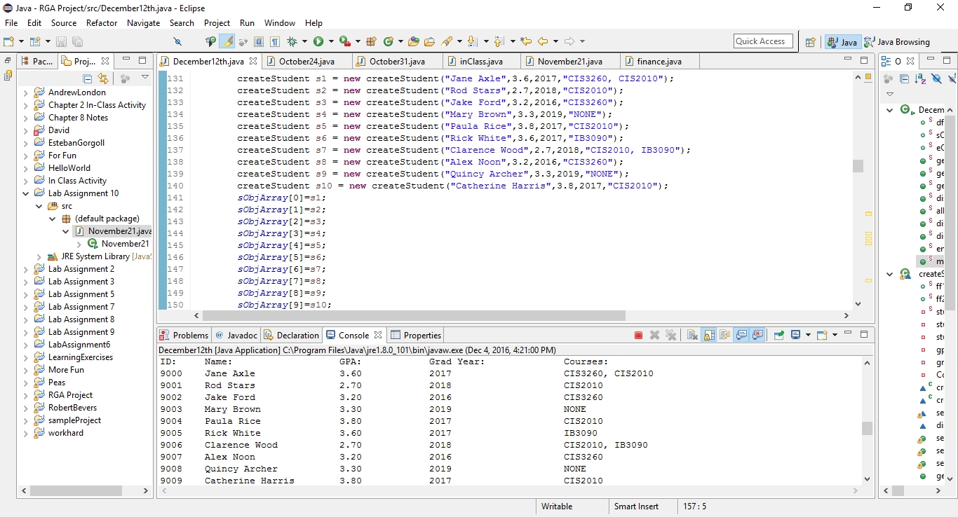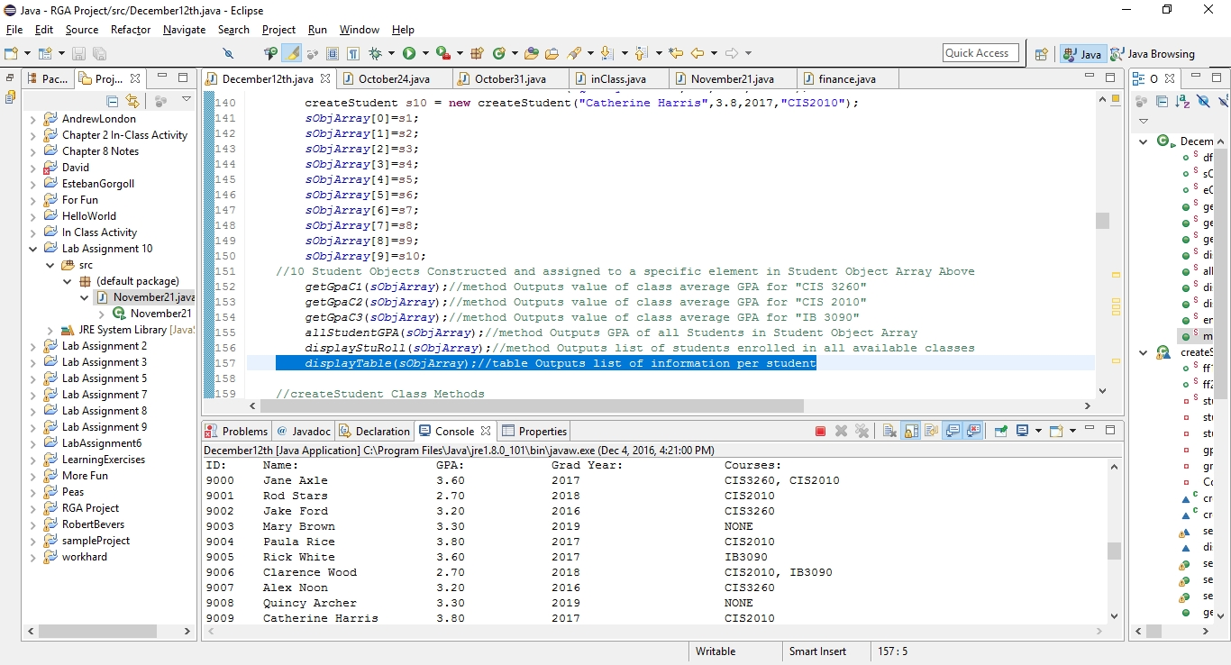

**Employee Specific Test Cases**

1. **You can create a new employee and assign him or her an employee ID, name, job, and**

**Date of employment.**



1. **You can modify an employee’s job**

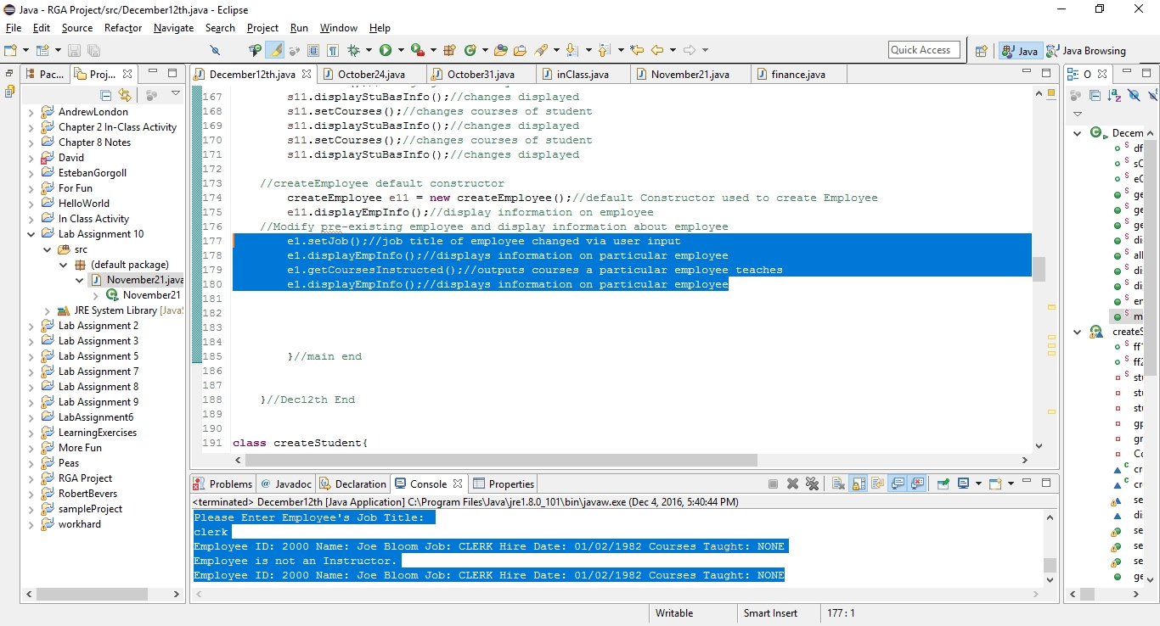

1. **Default values for job and date of employment are “” and 01/01/0001**

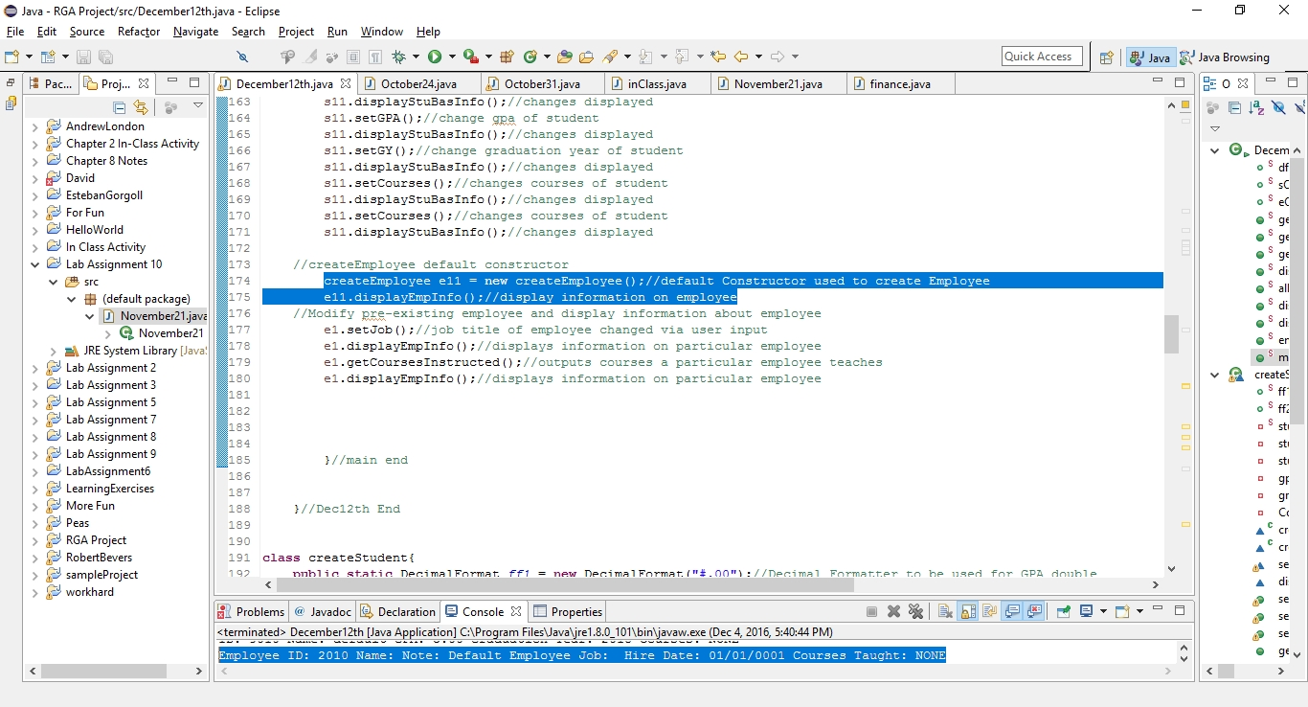

1. **If an employee is a teacher, then that employee can teach courses**

**&&**

1. **Display a given employee’s name, job, or date of employment**

**&&**

1. **Display the courses an instructor is teaching**

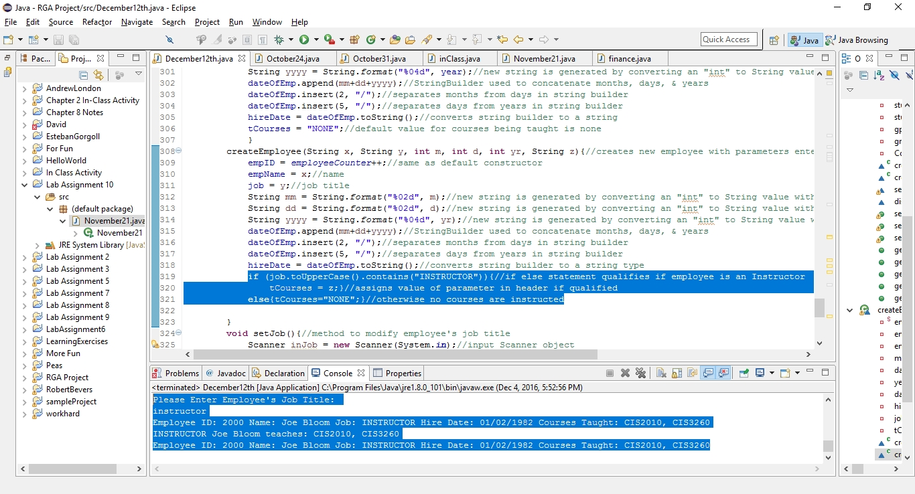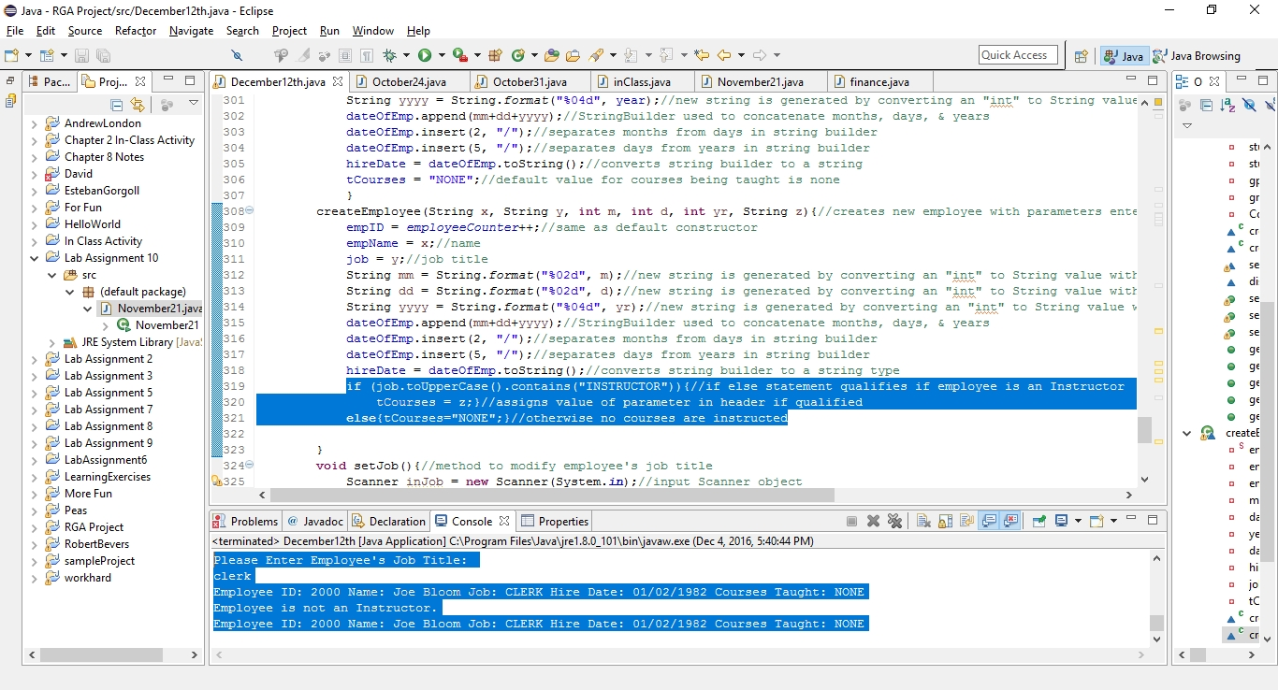

1. **Display a list of instructors teaching a particular course**

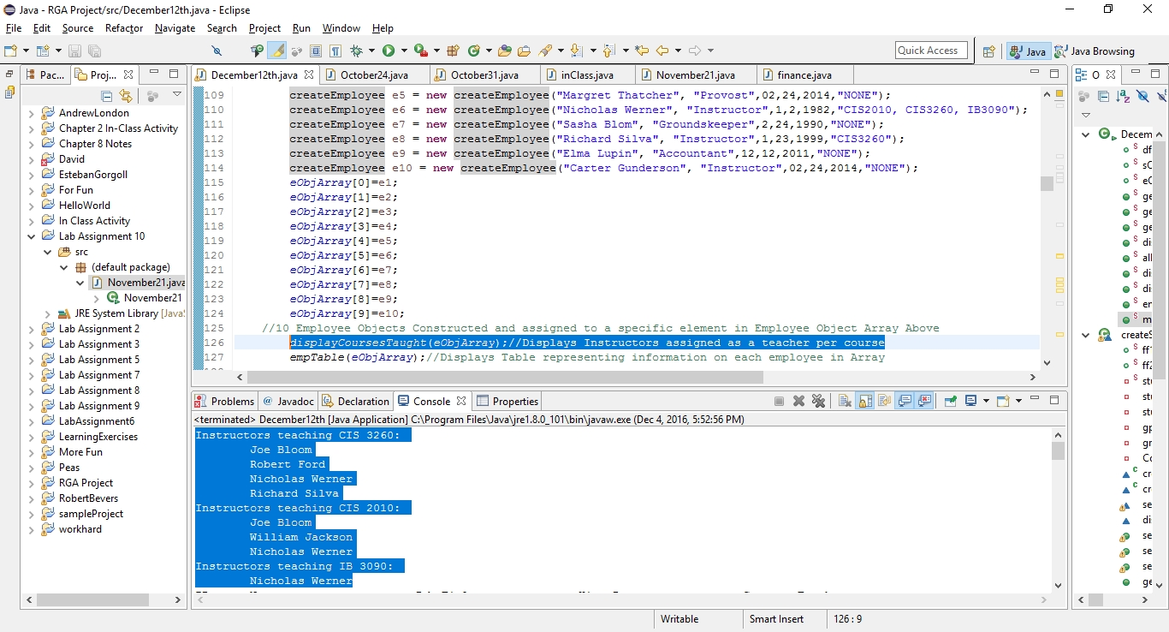

1. **Display Table of Employees**

